DBMS Lab

Assignment - 6

Dated: 15-03-2021

Sub Code: CSE-227

**Vivek Kumar Ahirwar**

**191112419**

**CSE - 3**

Department of

Computer Science and Engineering

Subject Coordinator:

Dr. Sweta Jain & Dr. Nikhil Kumar Singh



**Maulana Azad**

**National Institute of Technology,**

**BHOPAL – 462 003 (INDIA)**

Contents

Query 1 : Retrieve the names f all employee in dept. no. 5 who work for more than 10hrs./week on ‘projectX’ project. 2

Query 2 : List name of employee who have a dependent with same first name as themselves. 3

Query 3 : Find name of employee who are directly supervised by ‘Franklin Wong’. 4

Query 4 : For each project, list project name, total no. of hours spent on that project per week by all the employee. 5

Query 5 : Retrieve name of all employee who work on every project. 6

Query 6 : Retrieve name of all employee who don’t work on any project. 7

Query 7 : Retrieve dept. name and avg. salary of employee. 8

Query 8 : Find name and add of all employee who work on at least one project location in Houston but whose dept. has no location in Houston. 9

Query 9 : List last name of all department managers who have no dependents. 10

Query 10 : For each dept. whose avg employee salary is more than 30000, Retrieve dept. name and no. of employee working in the department. 11

Query 11 : Make list of project no. for projects that involve an employee whose LNAME IS ‘smith’ either as a worker or a managerof dept.that controls the project. 12

Query 12 : Find the list of employee who work on more than two projecrts. 13

Query 13 : Find employee whose salary > avg salary of his dept. 14

Limit Query 15

Create View Query 16

Drop View Query 17

# Query 1 : Retrieve the names f all employee in dept. no. 5 who work for more than 10hrs./week on ‘projectX’ project.

select Fname, Minit, Lname from employee, works_on, project

where ssn = essn and pno = pnumber and dno = 5 and hours >= 10

and pname = 'ProductX';

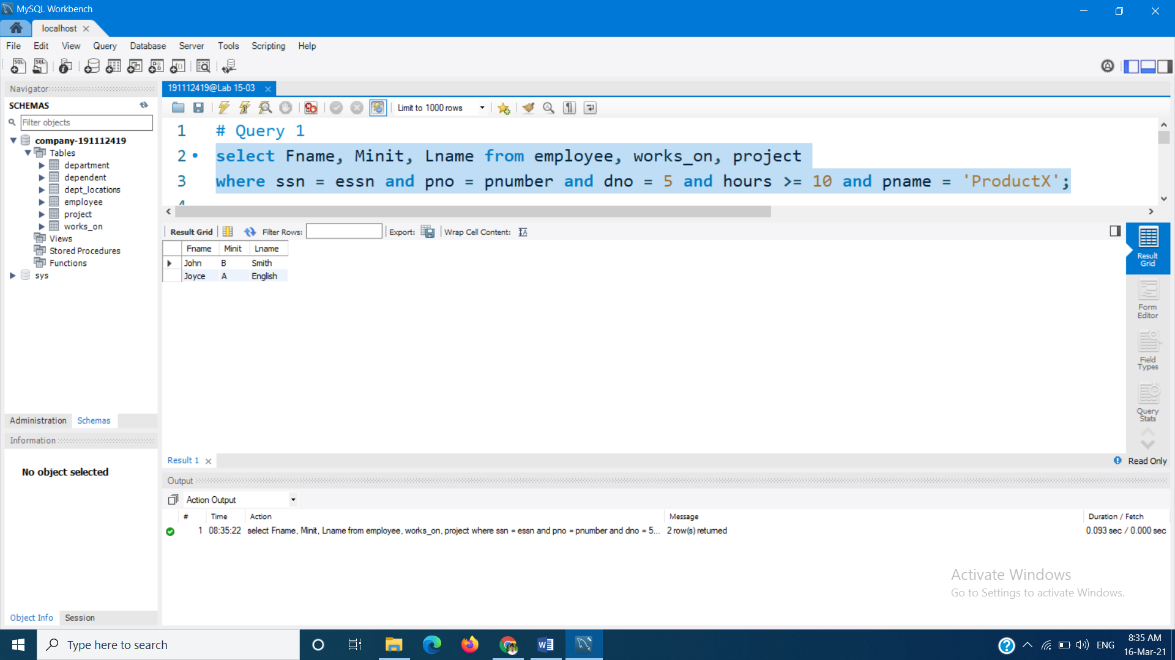

# Query 2 : List name of employee who have a dependent with same first name as themselves.

select Fname, Minit, Lname from employee join dependent on ssn = essn

where fname = Dependent_name;

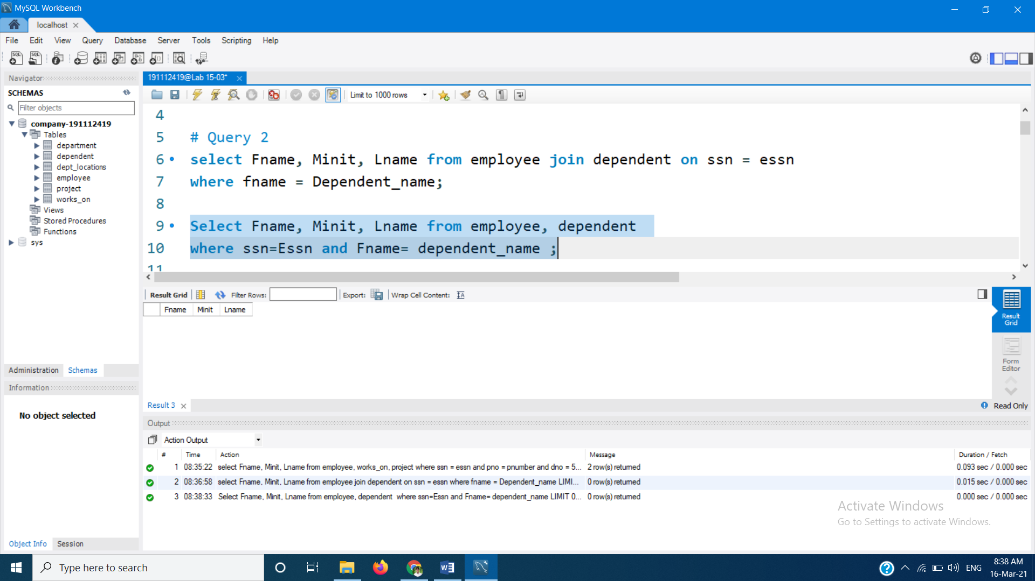

**Or**

select Fname, Minit, Lname from employee, dependent

where ssn=Essn and Fname= dependent_name;

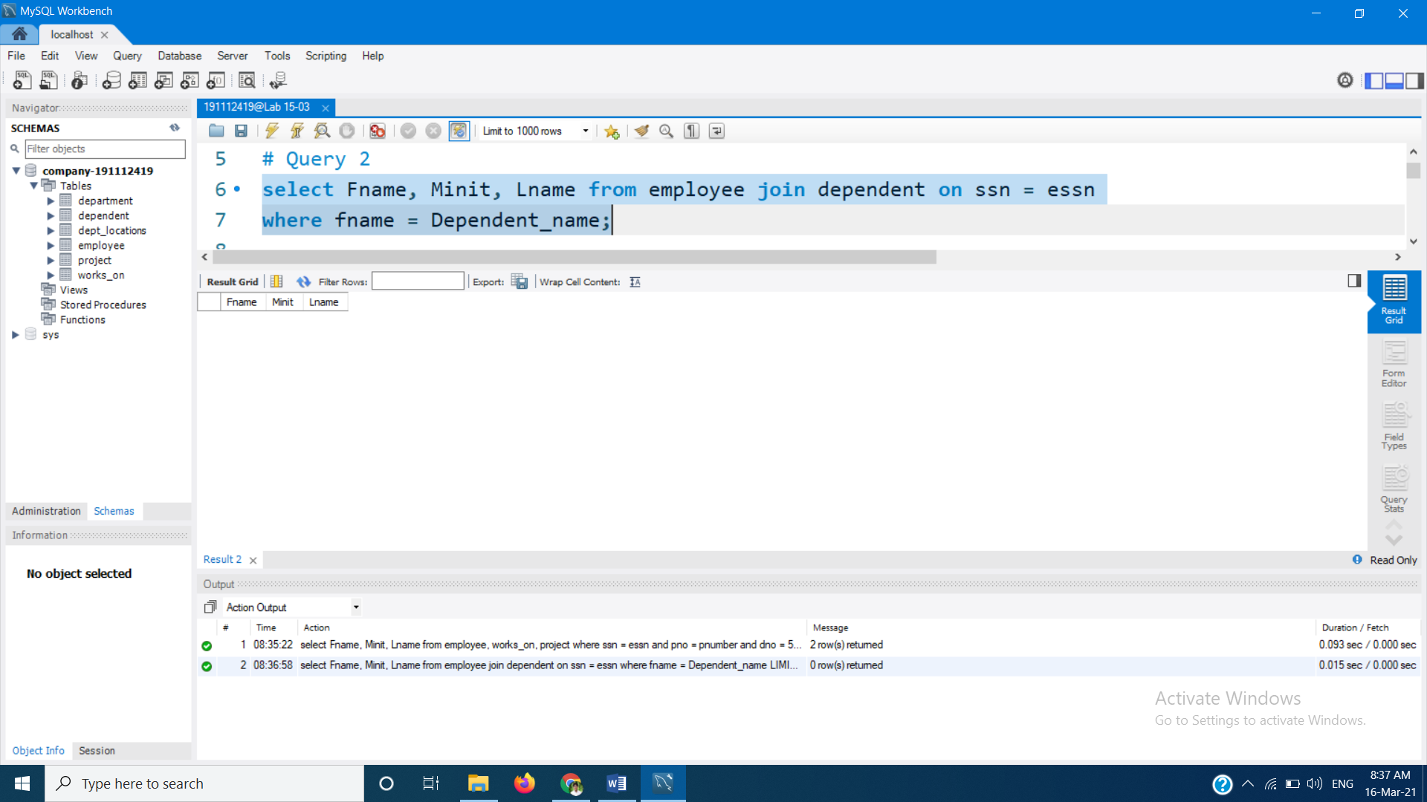

# Query 3 : Find name of employee who are directly supervised by ‘Franklin Wong’.

select emp.fname, emp.minit, emp.lname from employee as emp

where emp.Super_ssn in (select sup.ssn from employee as sup

where sup.fname = 'Franklin' and sup.Lname = 'Wong');

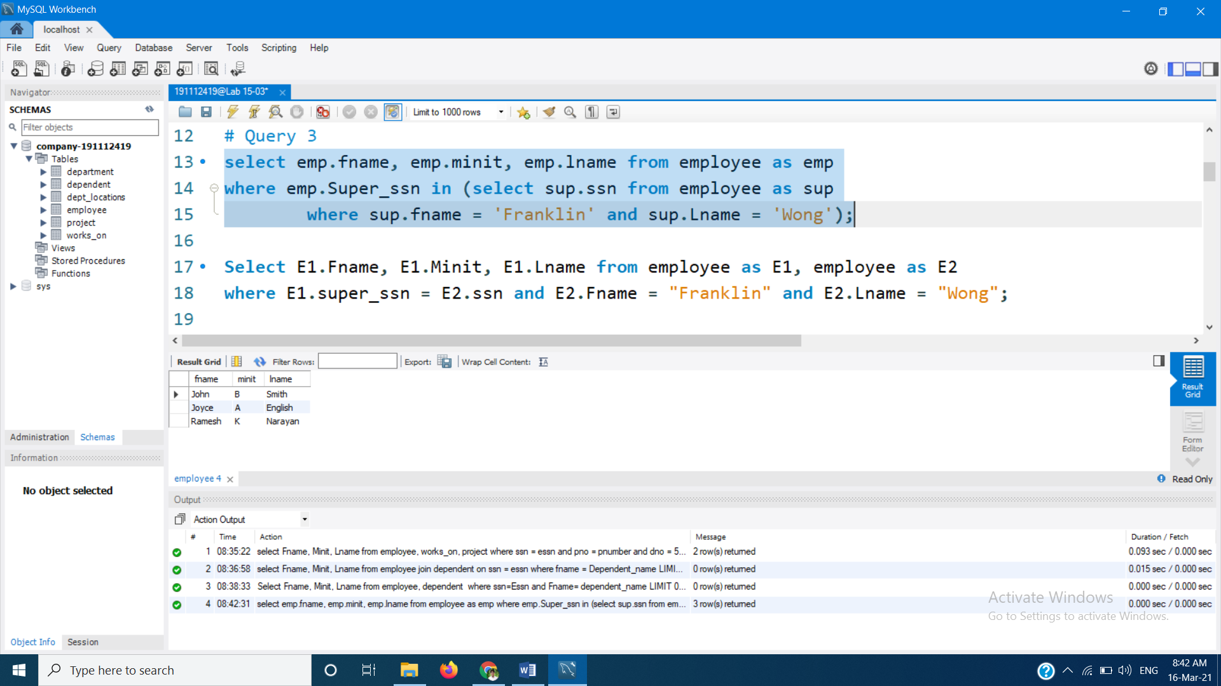

**Or**

Select E1.Fname, E1.Minit, E1.Lname from employee as E1, employee as E2

where E1.super_ssn = E2.ssn and E2.Fname = "Franklin" and E2.Lname = "Wong";

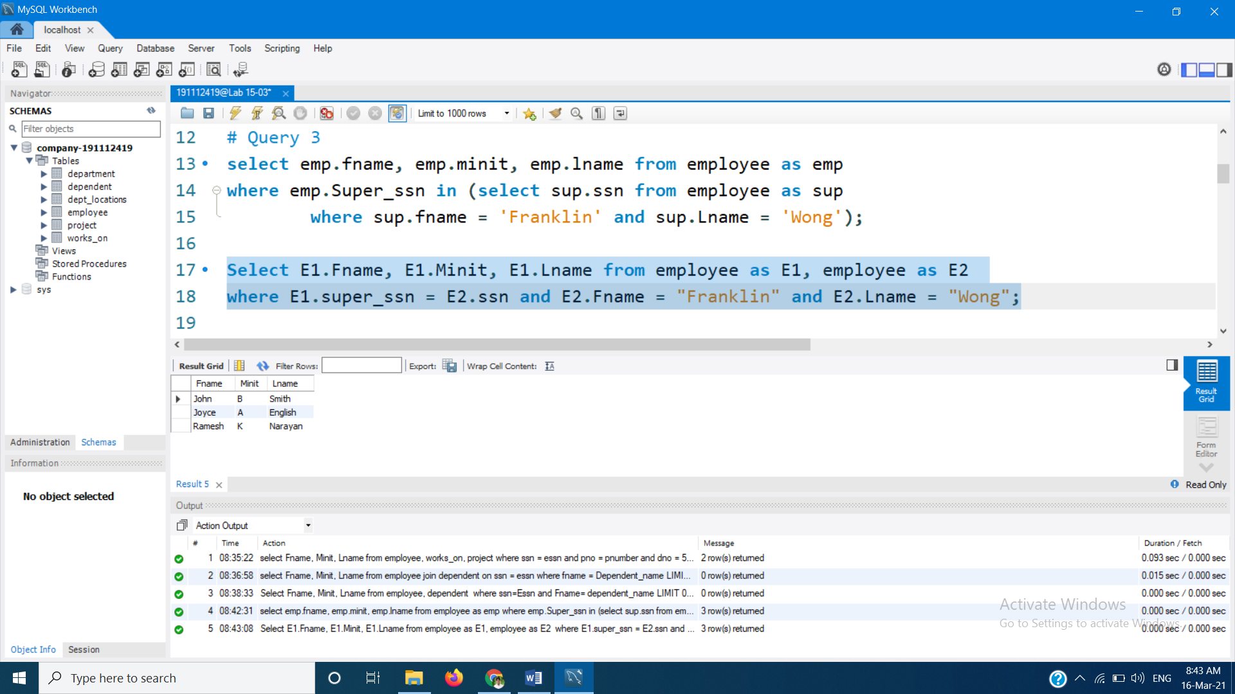

# Query 4 : For each project, list project name, total no. of hours spent on that project per week by all the employee.

select pname, sum(hours) as total_hours from project, works_on

where pnumber = pno

group by pname;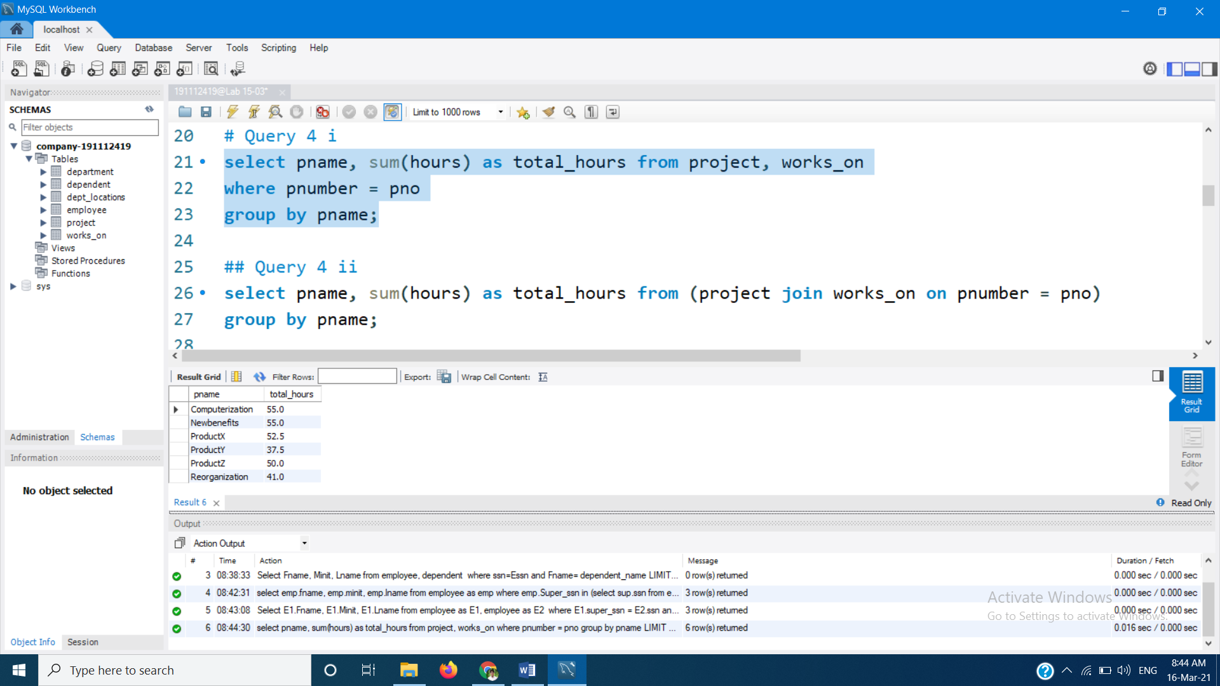

**Or**

select pname, sum(hours) as total_hours from

(project join works_on on pnumber = pno)

group by pname;

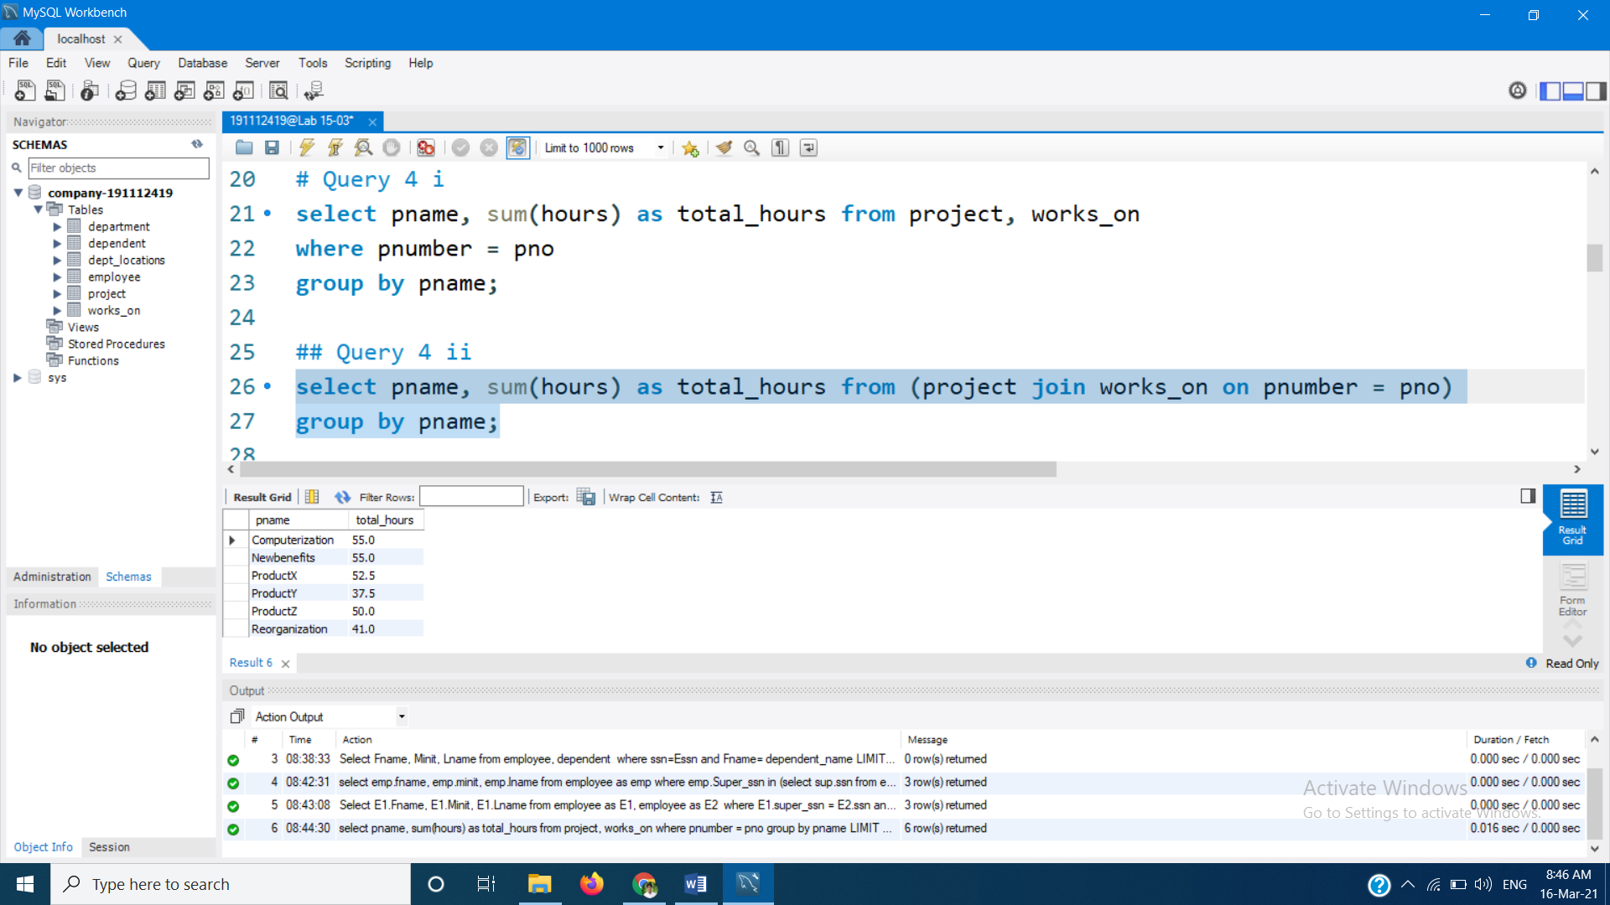

# Query 5 : Retrieve name of all employee who work on every project.

select fname, minit, lname from employee

where not exists ( select pnumber from project

where not exists (select 1 from works_on

where ssn = essn and pno = pnumber) );

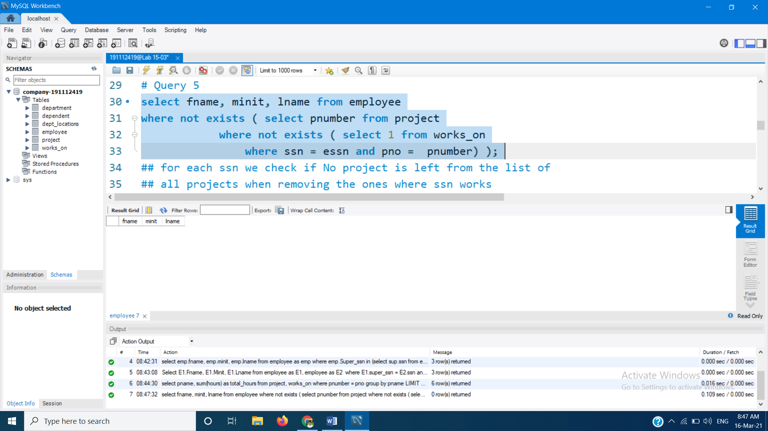

# Query 6 : Retrieve name of all employee who don’t work on any project.

select fname, minit, lname from employee

where ssn not in (select distinct essn from works_on);

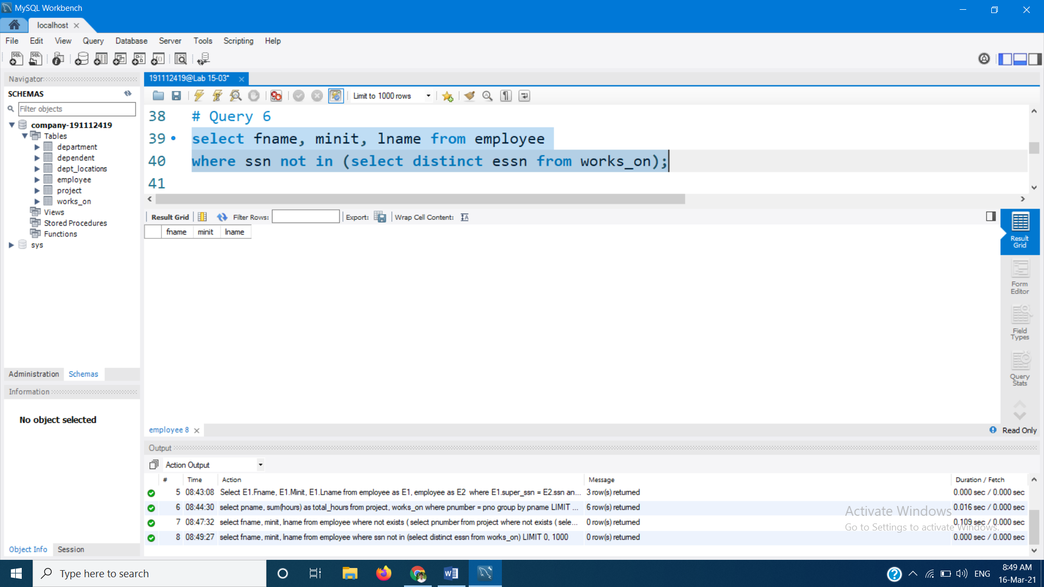

# Query 7 : Retrieve dept. name and avg. salary of employee.

select dname, avg(salary) from employee, department

where dno=dnumber

group by dno;

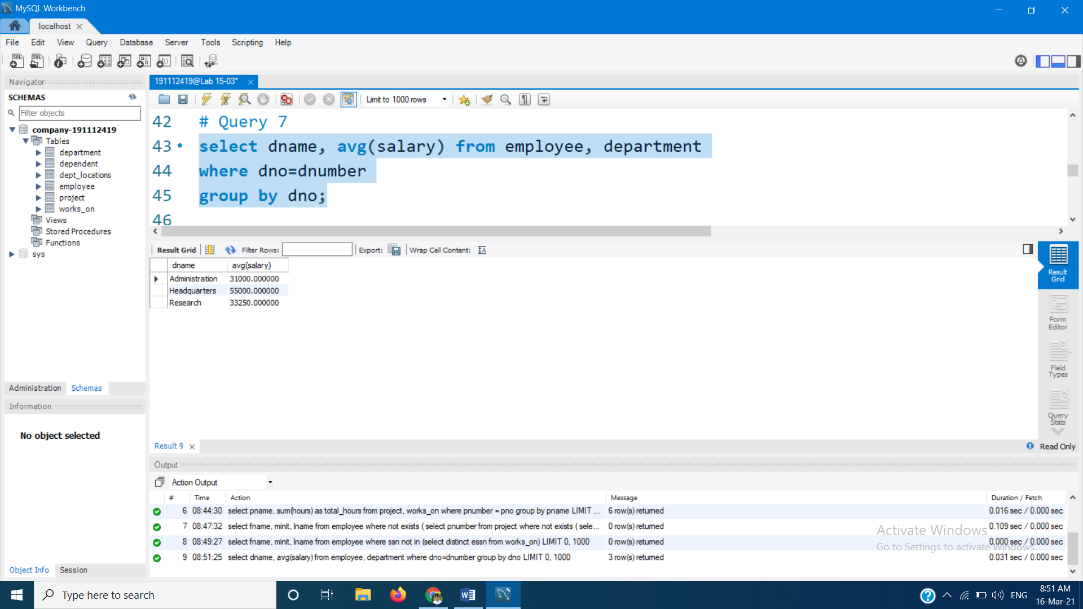

# Query 8 : Find name and add of all employee who work on at least one project location in Houston but whose dept. has no location in Houston.

select fname, minit, lname from employee join works_on on ssn = essn

where pno in (select pnumber from project where Plocation = 'Houston')

and dno not in (select dnumber from dept_locations

where dlocation = 'Houston');

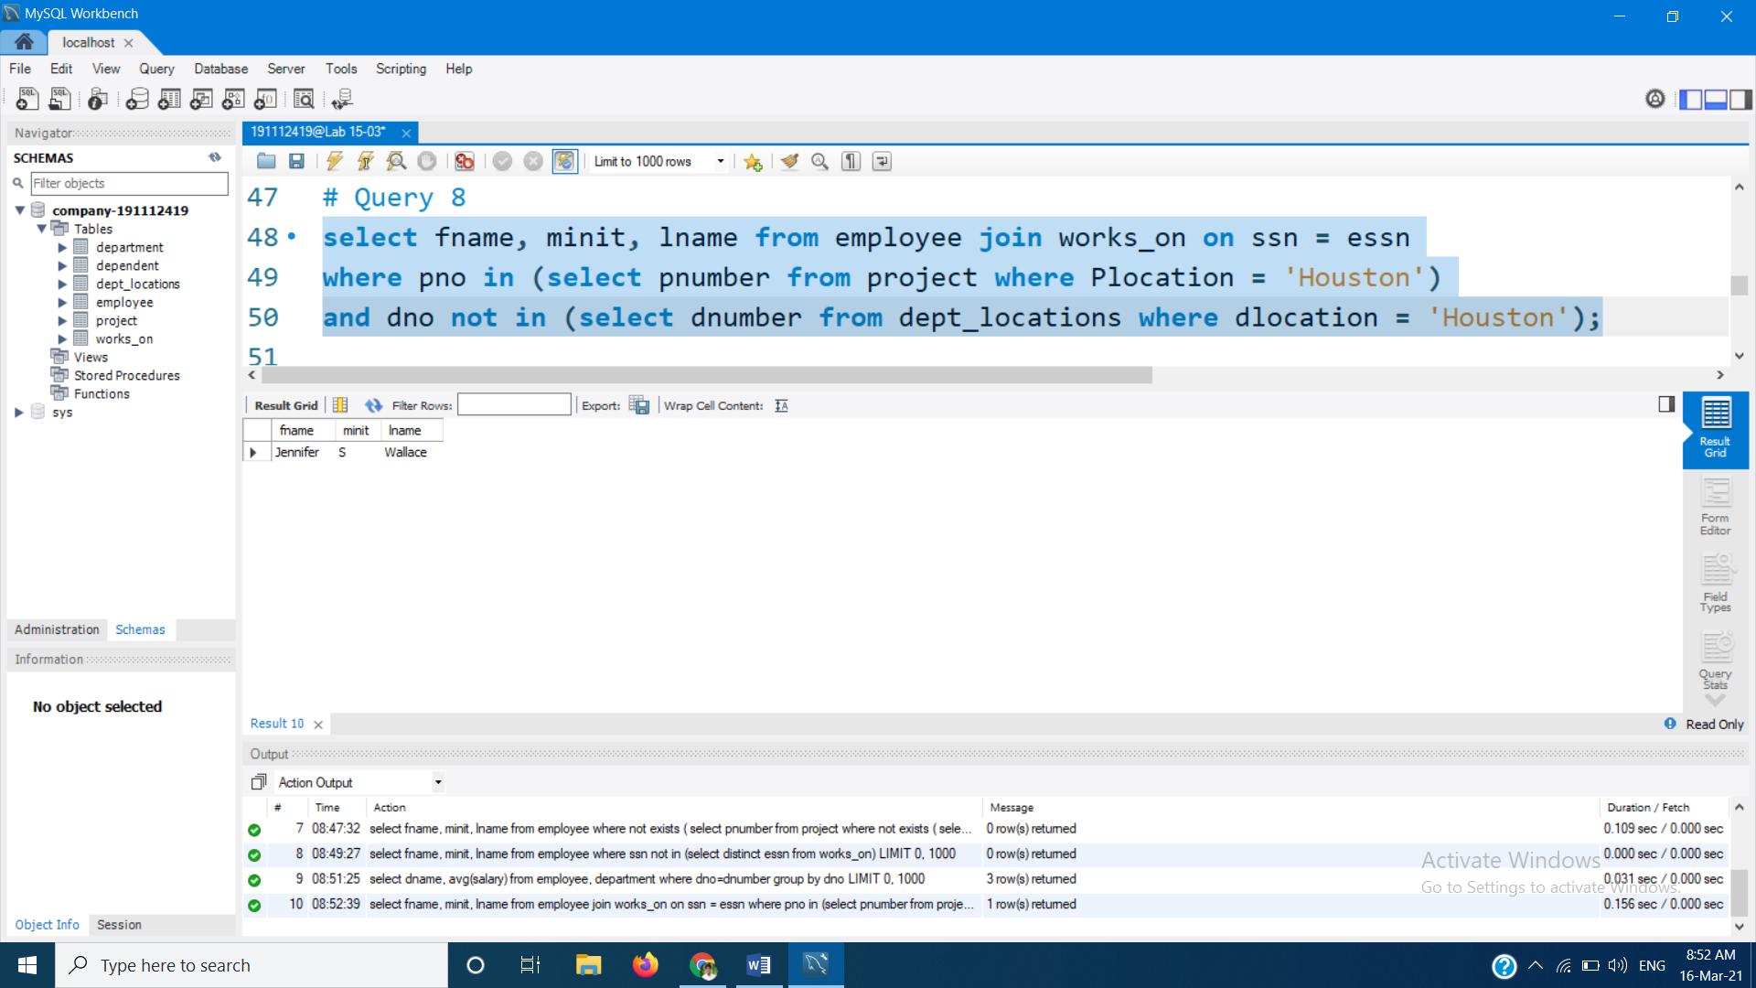

# Query 9 : List last name of all department managers who have no dependents.

select lname from employee, department

where ssn = mgr_ssn and

not exists ( select 1 from dependent where mgr_ssn = essn);

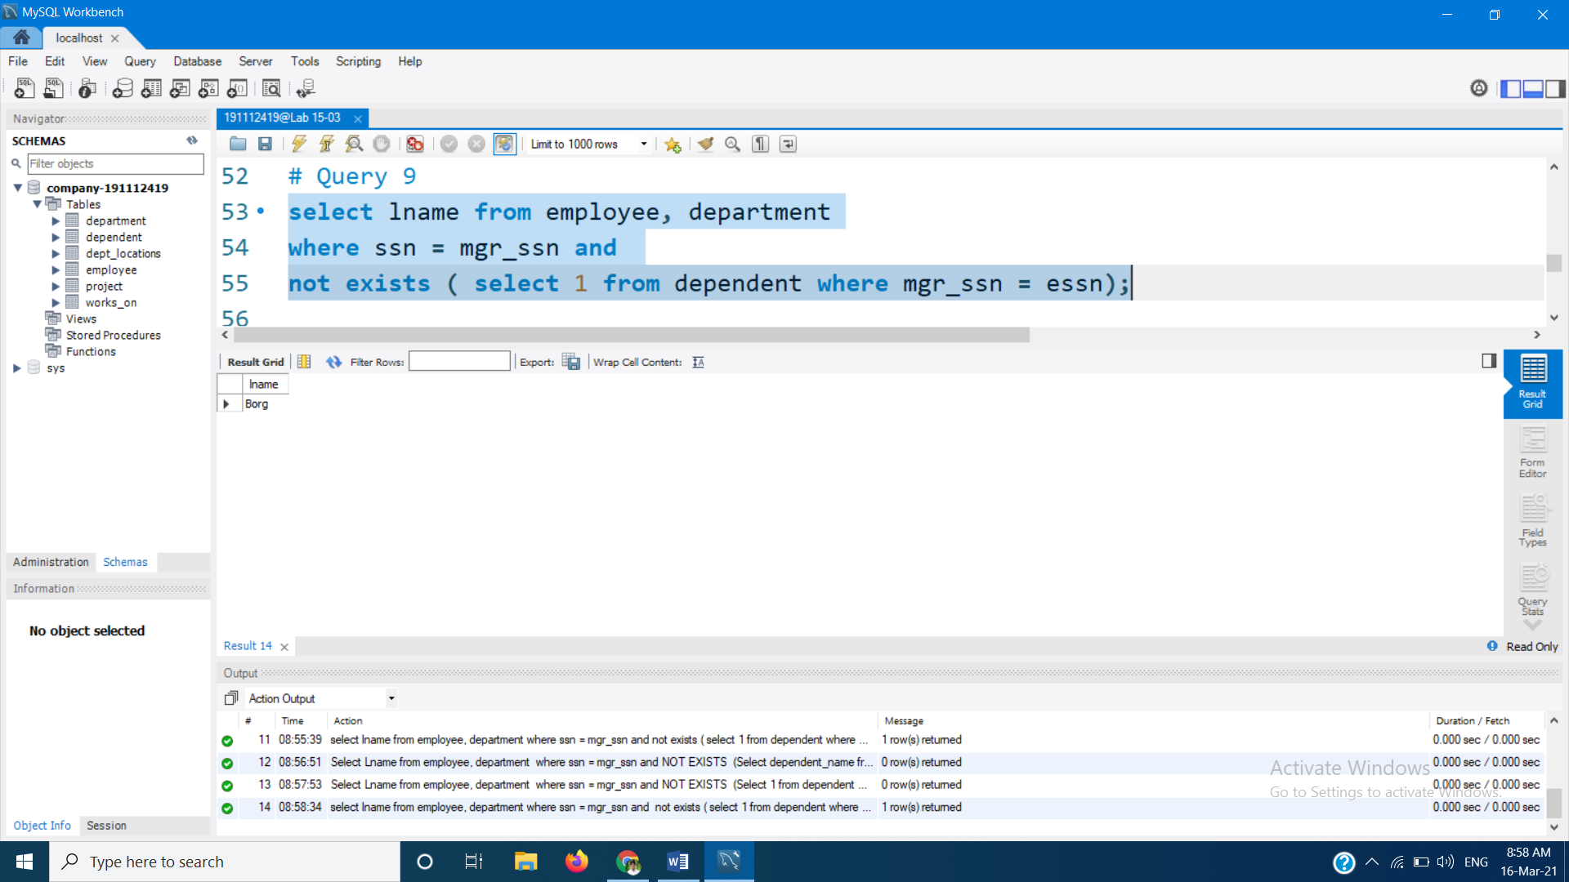

# Query 10 : For each dept. whose avg employee salary is more than 30000, Retrieve dept. name and no. of employee working in the department.

select dname, count(ssn) from employee, department

where dno = dnumber

group by dname

having avg(salary) >= 40000;

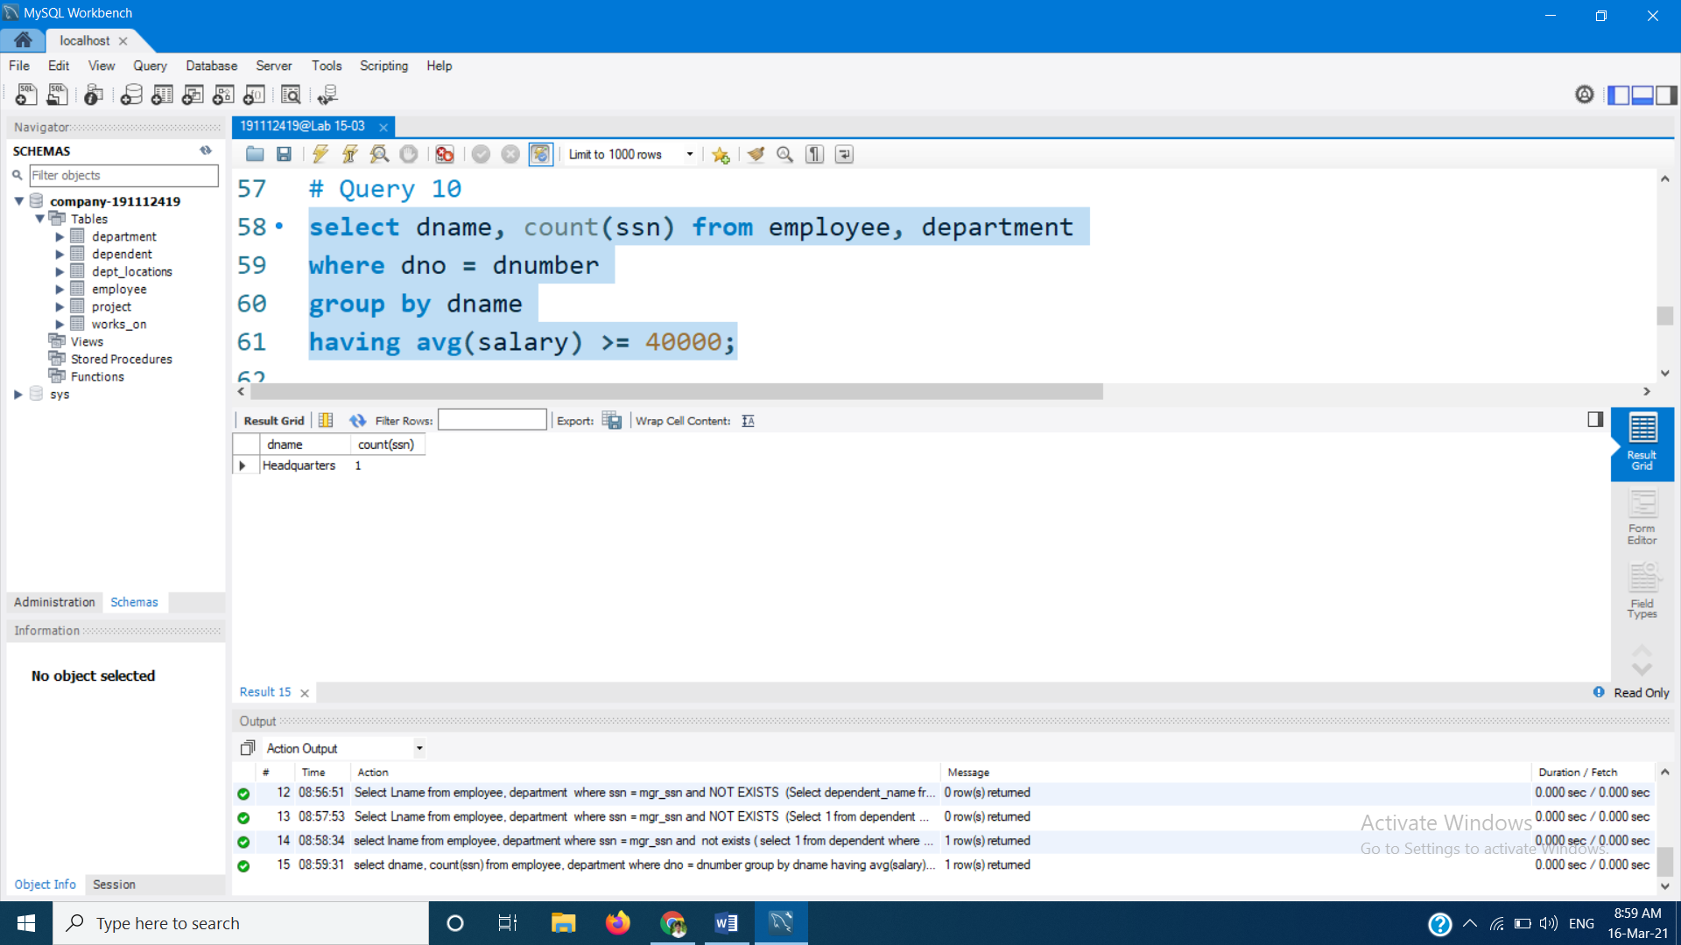

# Query 11 : Make list of project no. for projects that involve an employee whose LNAME IS ‘smith’ either as a worker or a managerof dept.that controls the project.

select distinct pno from employee, works_on

where ssn = essn and lname = 'Smith'

union all

select distinct pnumber from employee, project, department

where dnum = dnumber and mgr_ssn = ssn and Lname = 'Smith';

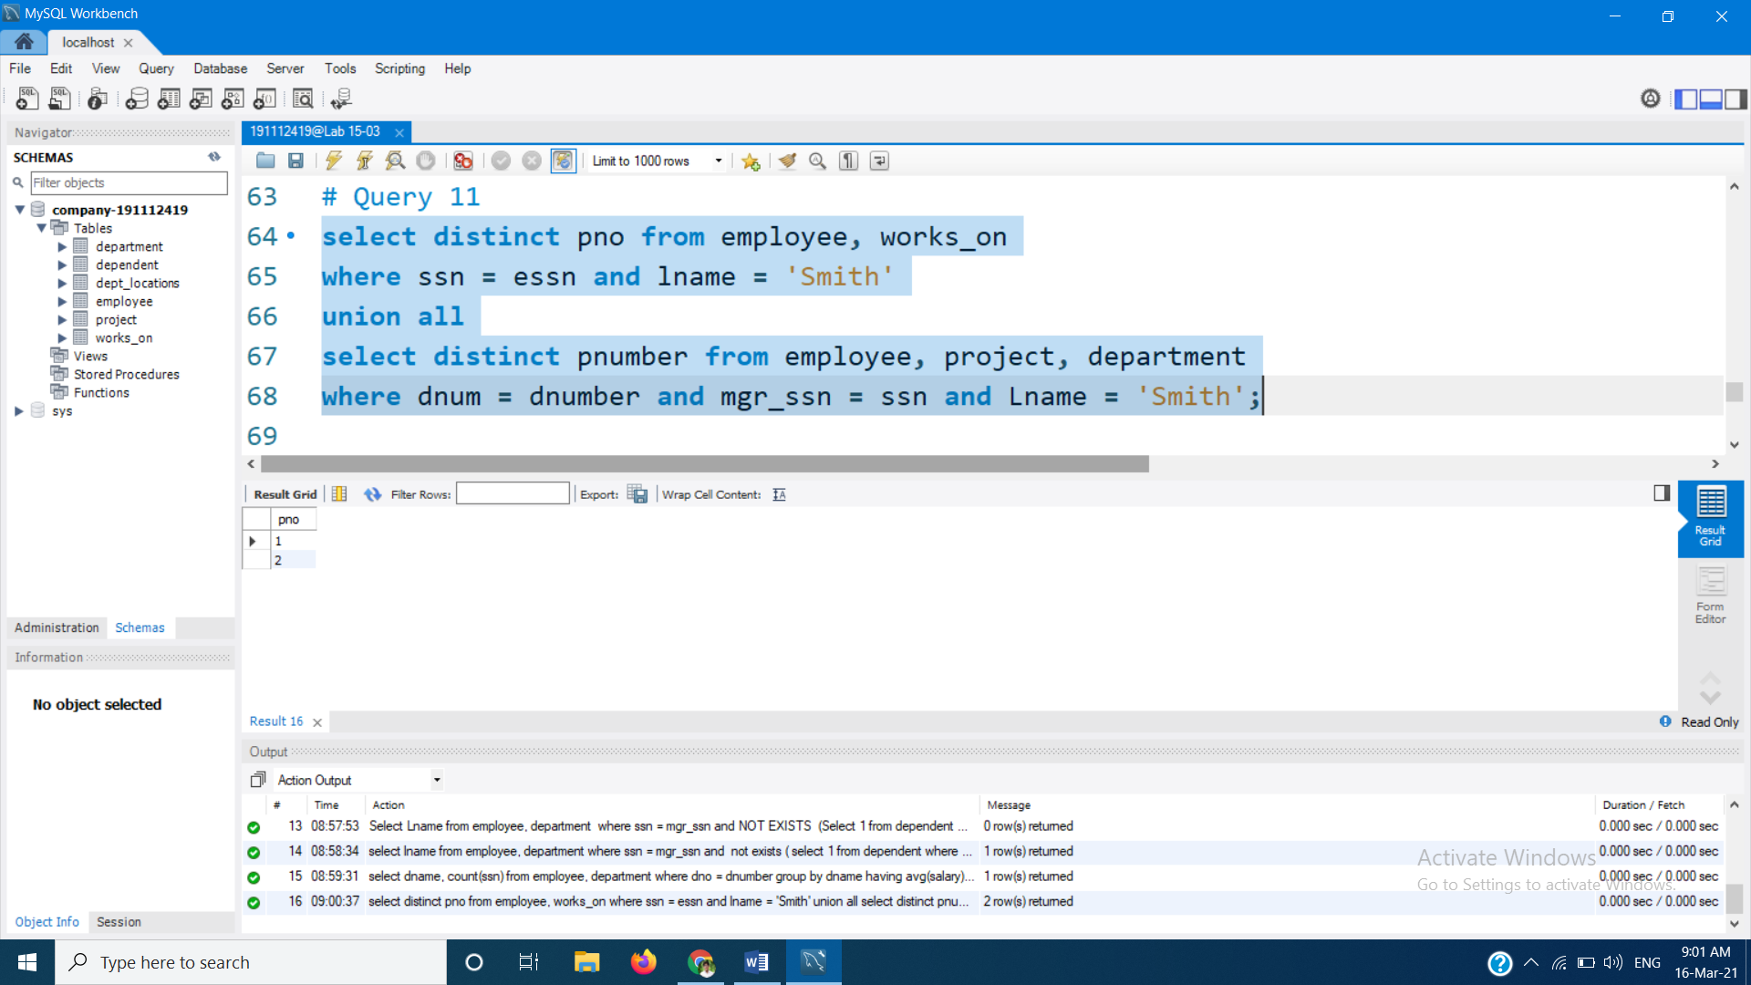

# Query 12 : Find the list of employee who work on more than two projecrts.

select fname, minit, lname from employee

where ssn in ( select essn from works_on as w

group by essn having count(pno) > 2 );

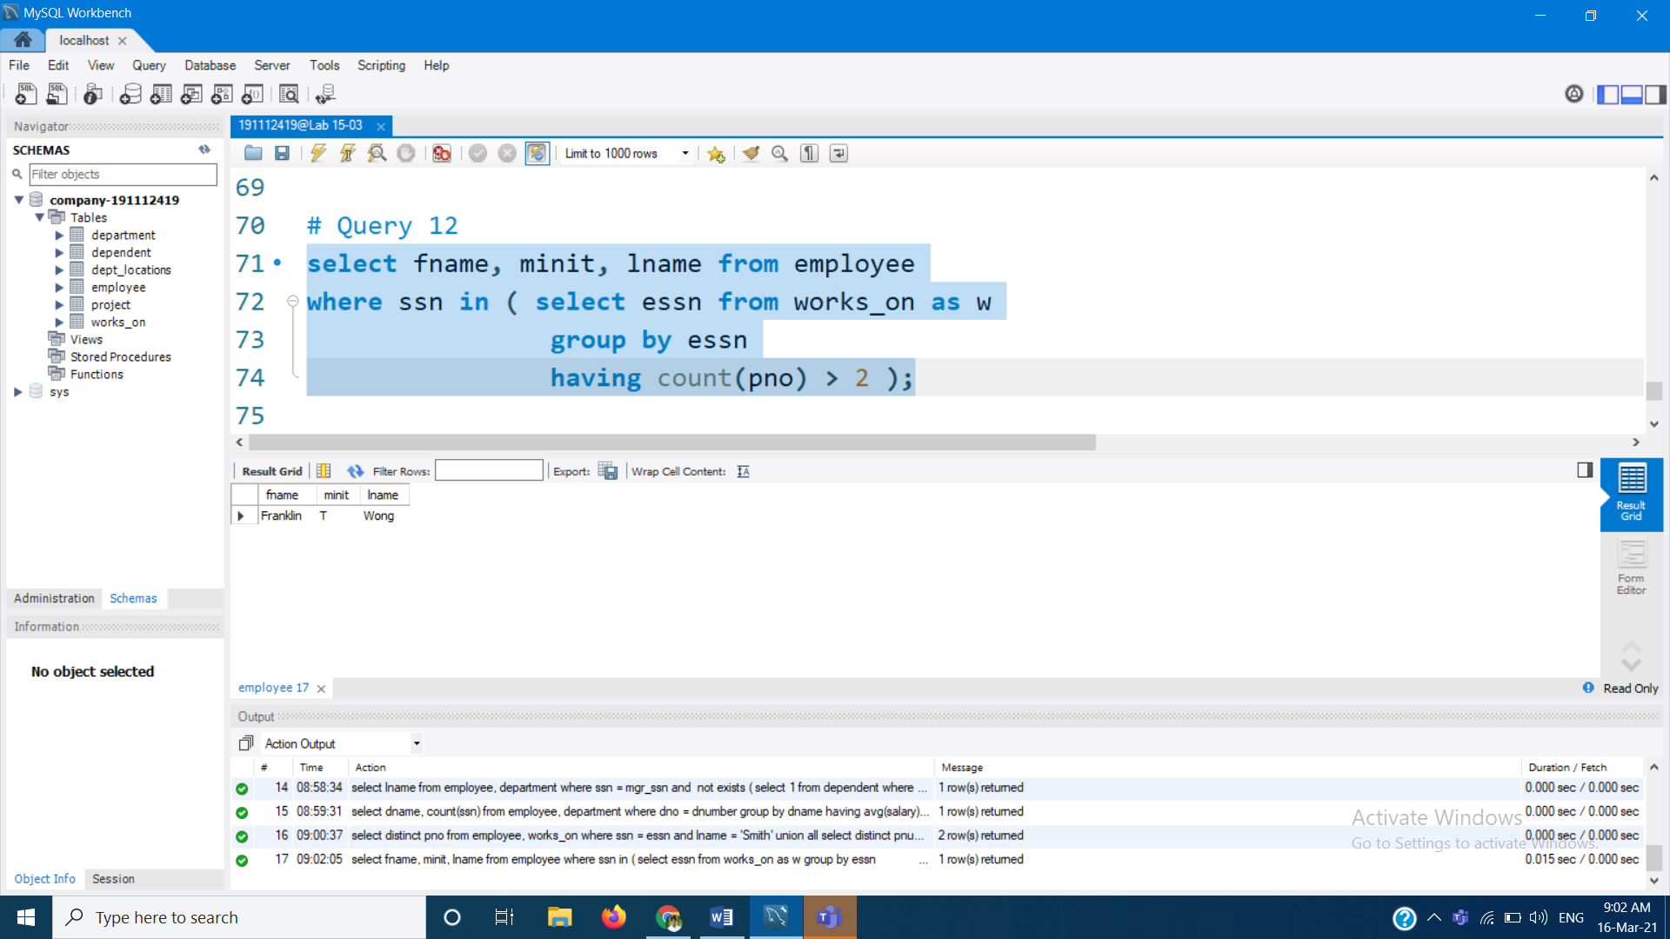

# Query 13 : Find employee whose salary > avg salary of his dept.

select emp.fname, emp.lname from employee as emp

where emp.salary > (select avg(emp2.salary) from employee as emp2

where emp.dno = emp2.dno);

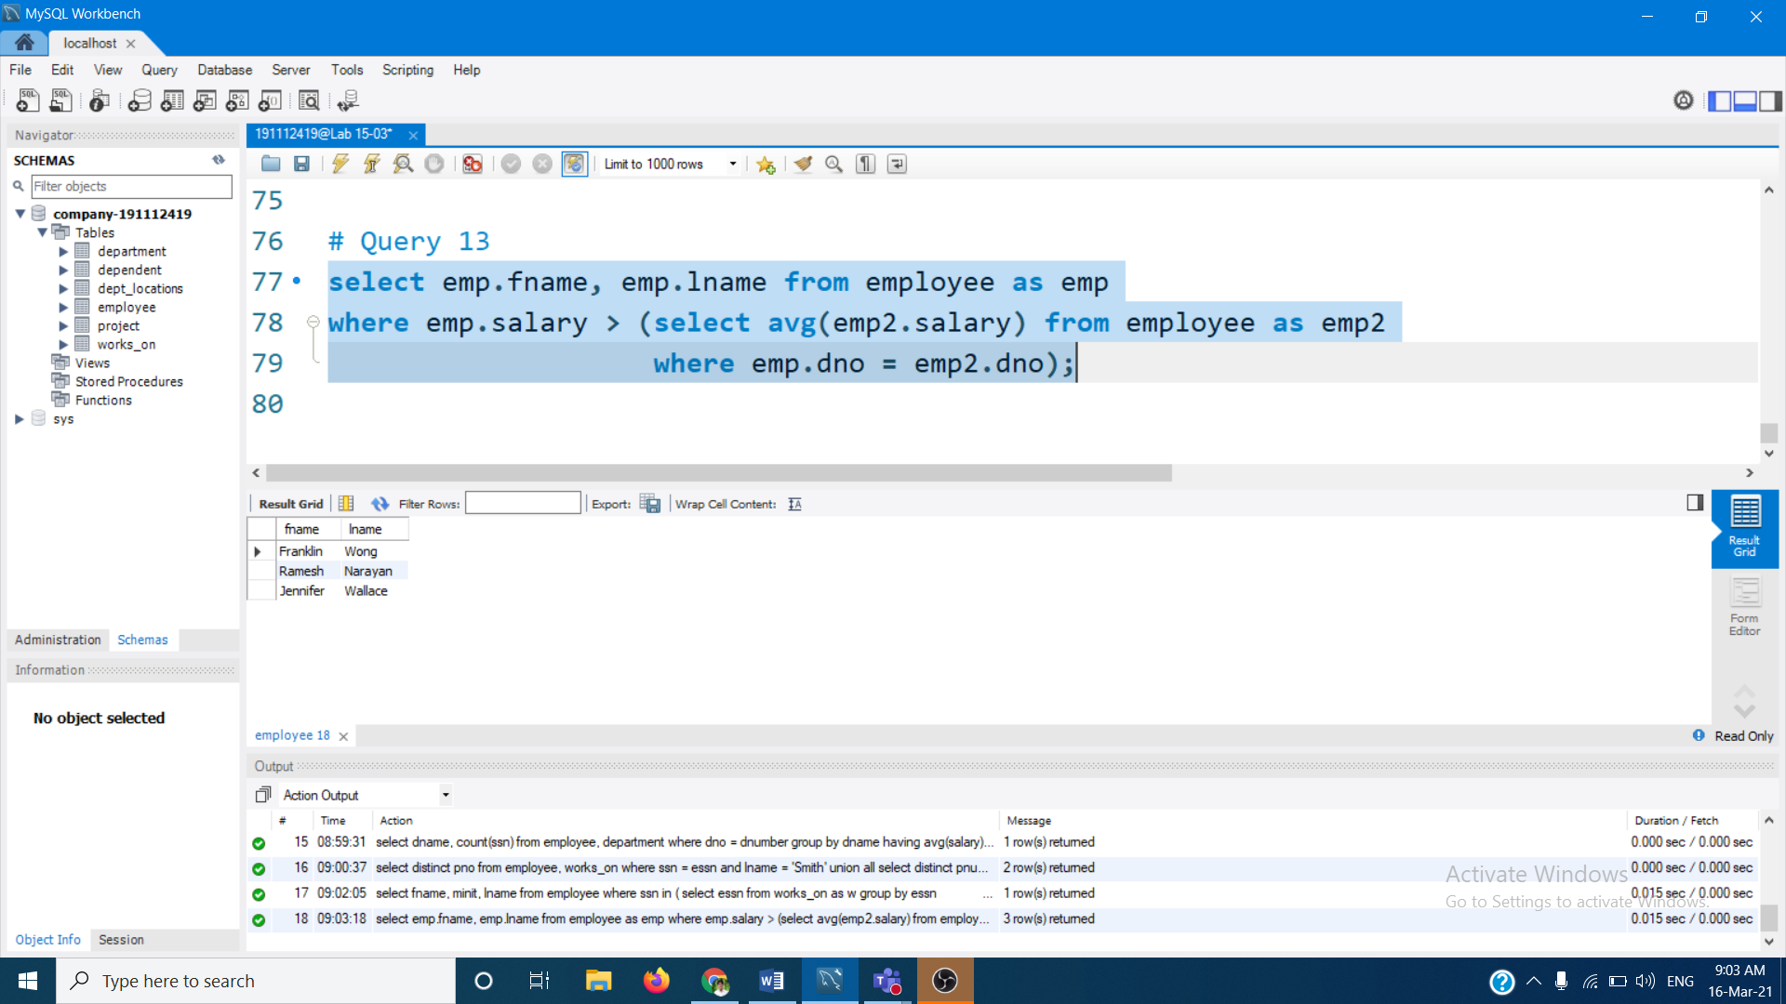

# Limit Query

select * from employee limit 5;

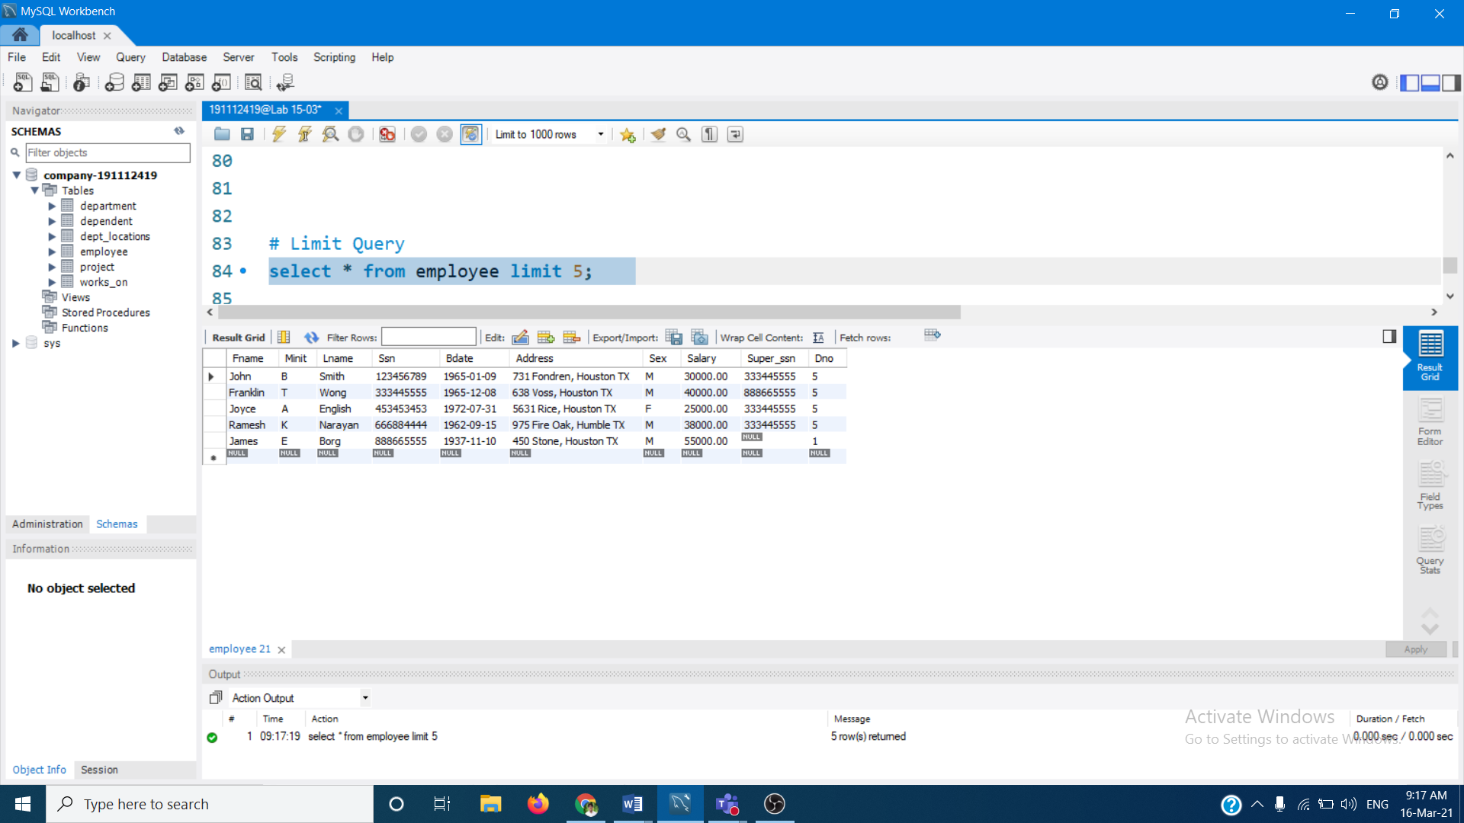

# Create View Query

create view project_work as

select concat(fname,' ', Minit, '. ', Lname) as Name,

Pname as Project, Hours

from employee, project, works_on

where Ssn = Essn and Pno = Pnumber;

select * from project_work;

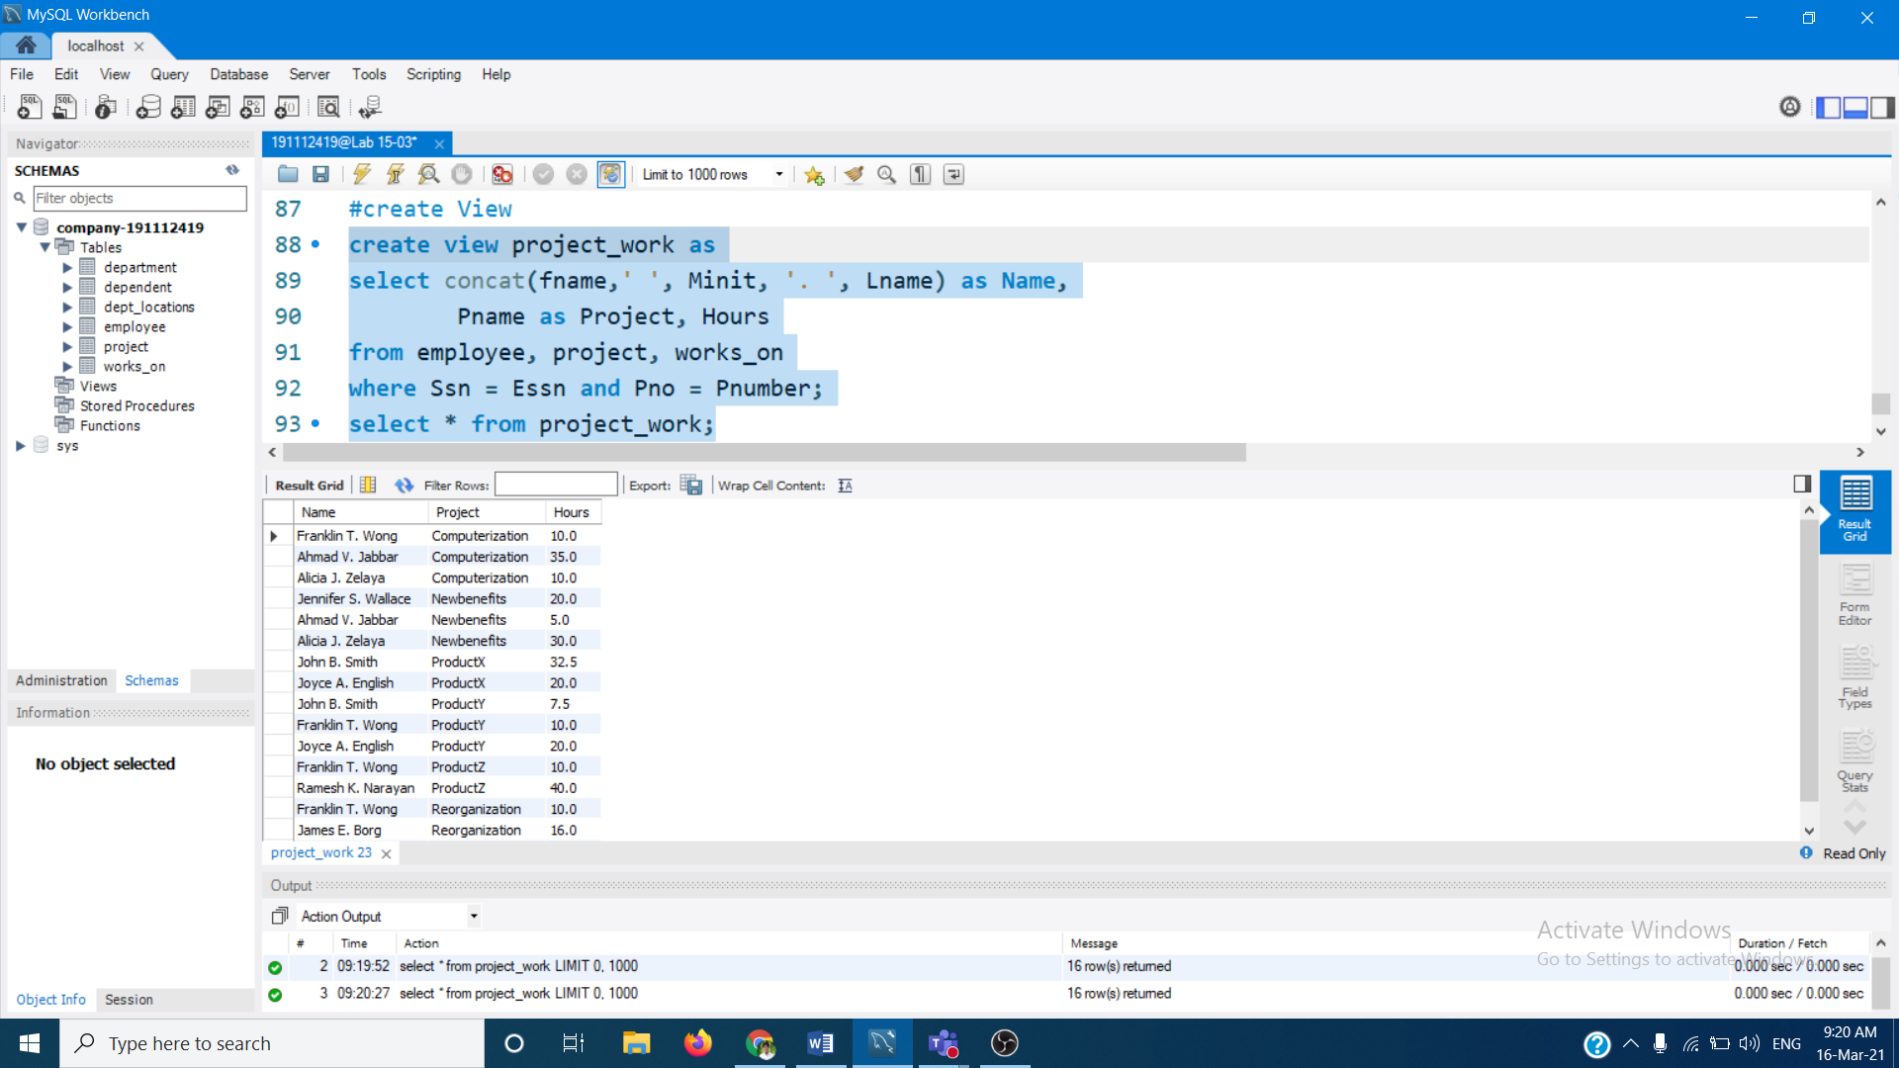

# Drop View Query

drop view project_work;

